DOCKER - 02
- Create a tomcat container on 8080 and deploy sample application in tomcat.
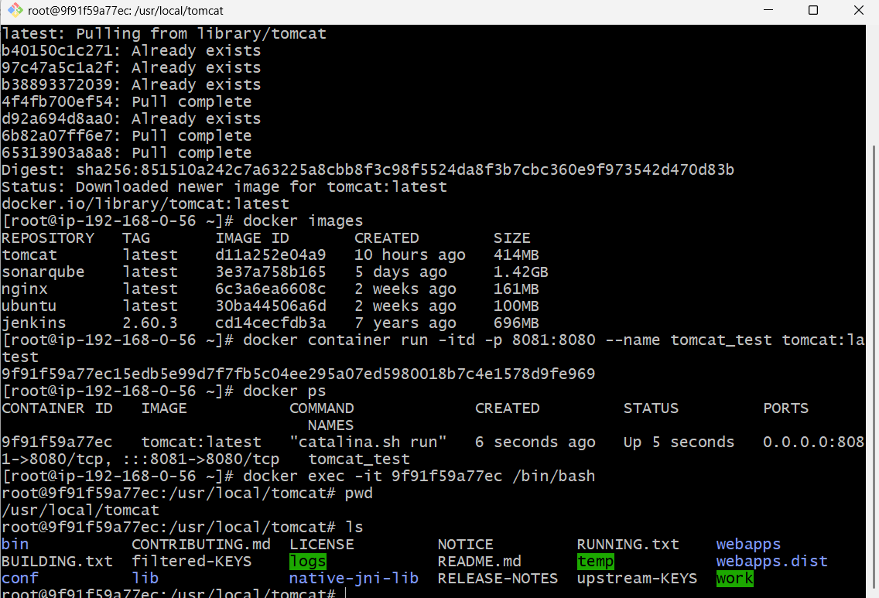
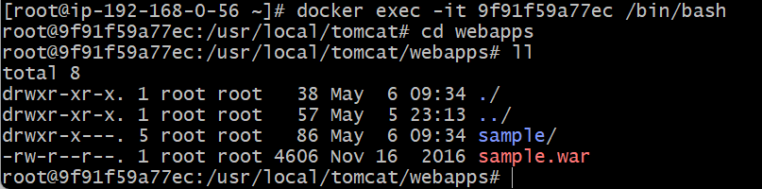
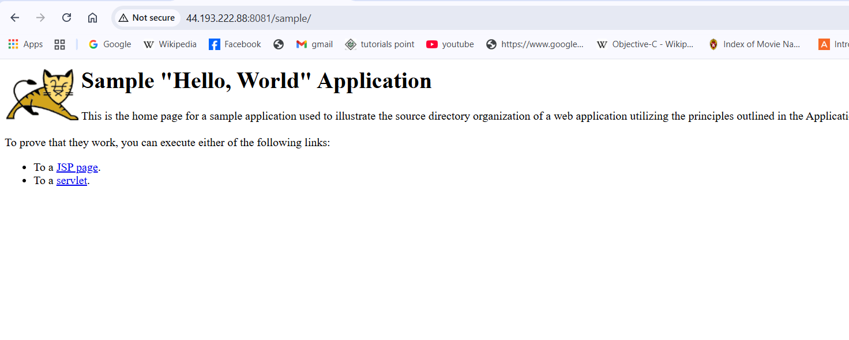
- Create volume and deploy tomcat container on port 8081.
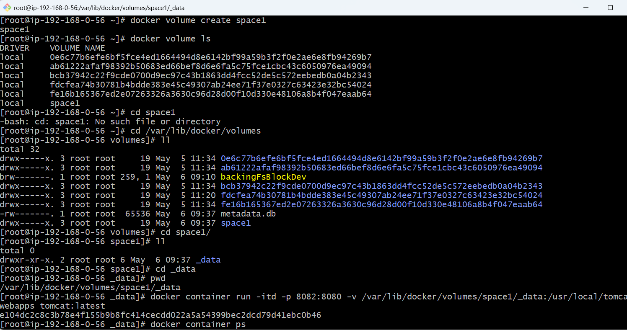
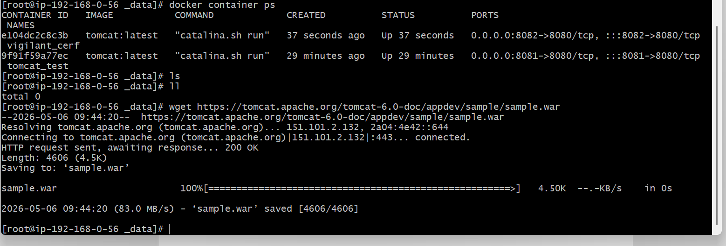

- Limit the nginx container to 500 MB.
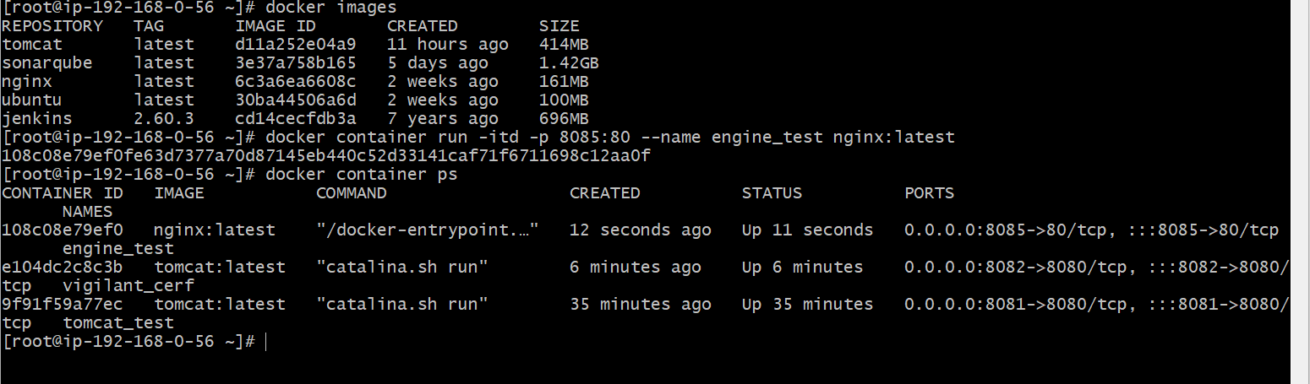
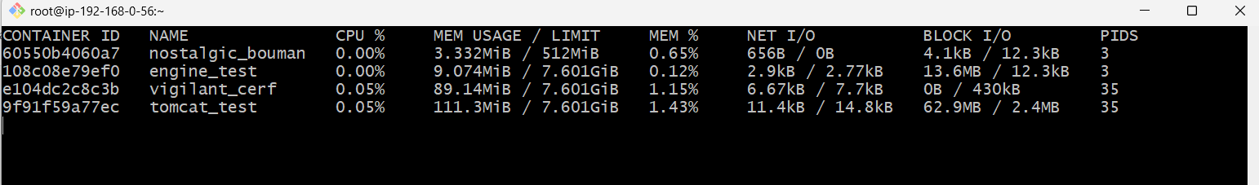
- Create a sample docker file using below instructions.
Base module as amazonlinux:latest
Maintainer you name
Install nginx
COPY one index.html file to image
Expose on port 80
- Command to start the nginx container
- Push image to Docker hub
- push image to AWS ECR
